Project Design Phase-II

Data Flow Diagram &User Stories

|  |  |
| --- | --- |
| Date | 17-October-2023 |
| TeamID | ABDCDB652241D6FA0144AC94B95F5433 |
| ProjectName | Quantitative Analysis of Candidates In 2019 Lok Sabha |
| MaximumMarks | 4 Marks |

# Data Flow Diagrams:

A Data Flow Diagram (DFD) is a traditional visual representation of the information flows within a system. A neat and clear DFD can depict the rightamount of the system requirement graphically. It shows how data enters and leaves the system, what changes the information, and where data isstored.

# Example:[(Simplified)](https://developer.ibm.com/patterns/visualize-unstructured-text/)

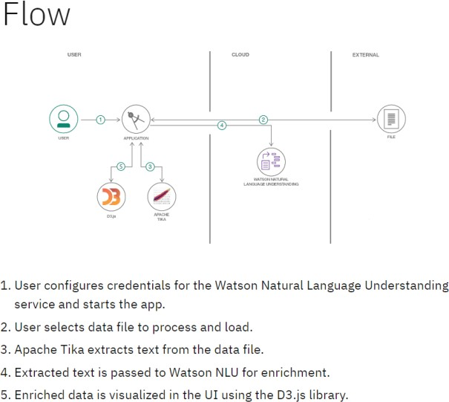

DATA FLOW DIAGRAM

PUBLIC USER

**User Stories**

Use the below template to list all the user stories for the product.

|  |  |  |  |  |  |  |
| --- | --- | --- | --- | --- | --- | --- |
| **UserType** | **Functional**  **Requirement(Epic)** | **UserStoryNumber** | **UserStory/Task** | **Acceptancecriteria** | **Priority** | **Release** |
| PUBLIC | check water quality information for their area | USN-1 | Public users can access the system to check the quality of water in their area. They can view real-time water quality information, including potability status. | I can access my account /dashboard | o/1 |  |
|  |  | USN-2 | Public users may set preferences to receive real-time alerts and notifications about water quality issues, such as water contamination or safety concerns. |  | 0/1 |  |
|  |  | USN-3 | They can access historical water quality data to track changes and trends in water quality over time |  | 0/1 |  |
|  | Dashboard |  |  |  |  |  |
| System Administrator |  |  | Infrastructure Management: System administrators are responsible for managing the technical infrastructure, including servers, databases, and software updates. They ensure that the system is running smoothly and efficiently. |  |  |  |
|  |  |  |  |  |  |  |
|  |  |  |  |  |  |  |
|  |  |  |  |  |  |  |